DLMS Message Code
Mac Header || Grouping Header || Payload
Ex: Set Clock
DD 00 00 00 00 00 00 82 00 EE 11 00 00 00 00 DF 09 01 00 00 00 00 00 00 00 46 08 FE DC BA 98 76 54 32 10 08 00 22 A3 00 00 01 4C 33 00 02 00 62 7A D9 20 00 00 06 00 05 03 00 08 00 00 01 00 00 FF 09 02 00 08 00 00 01 00 00 FF 05 03 00 08 00 00 01 00 00 FF 04 01 00 08 00 00 01 00 00 FF 02 01 00 08 00 00 01 00 00 FF 04 05 16 05 02 03 09 0C FF FF FF FF FF FF FF FF FF 80 00 FF 09 0C 07 DF 03 0D 04 09 02 03 00 00 00 00 09 0C 07 DF 03 0D 04 09 02 03 00 00 00 00 0F 00 09 0C 07 DF 03 0D 04 09 02 03 00 00 00 00 16 00 40 7E A1 0A FF 49 77 94 EE 48 68 37 DB F1 33 C4 C7 B9 B1 4A E3 26 DB 19 E5 56 93 89 7A 8F 95 97 DD 8F 4D 18 BE 2D 71 30 00 57 34 77 91 23 11 4C 05 4C BA F6 45 55 BF 6D 24 68 F4 1E 91 CA 52 B2 72 E3 88 A4 AB 9B 32 5A 1E DE 01 71 87
########################### MAC Header(General Ciphering)############################
DD 00 00 00 00 00 00 82 00 EE 11 00 00 00 00
Tag (General Ciphering)
DD Green Book (Tag for General Ciphering)
00 00 00 00 00 00 (Fixed Value)
General-Ciphering ::= SEQUENCE
{
transaction-id: OCTET STRING, (Zero length, No value)
originator-system-title: OCTET STRING,(Zero length, No value)
recipient-system-title: OCTET STRING,(Zero length, No value)
date-time: OCTET STRING,(Zero length, No value)
other-information: OCTET STRING,(Zero length, No value)
key-info: OPTIONAL, (As GBCS 4.3.3.4, DLMS COSEM AK shall not be present)
ciphered-service: OCTET STRING (Length 1 to 3)
}

ciphered-service: OCTET STRING
82 00 EE
Encoded length in octets of the whole of the remaining APDU.

Security Control Byte (Length=1)
11
In this 3..0 Security suits. Since security suit 1 is required (Section 7.2.5 GBCS)
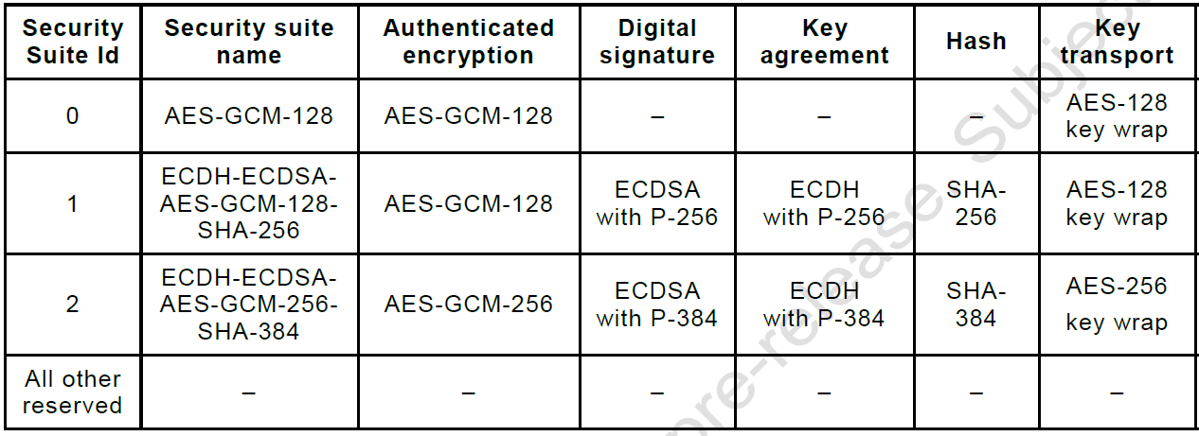

Bit 4 : Indicate Authentication is applied (1, Authentication of APDU is required)
Bit 5: Indicate Encryption is applied (0, Whole of APDU is never Encrypted)
Bit 6: 0 =Uni cast, 1= Broadcast (0, messages with MAC are uni cast)
Bit 7: Indicate use of compression
Invocation Counter (Length =4)
IC is always zero. (GBCS 8.4)
00 00 00 00
When new key establish IC reset to 0. Which is increments upon each invocation of the authentication encryption function using the same key.

################################ Grouping Header (General signing) ##########################
DF 09 01 00 00 00 00 00 00 00 46 08 FE DC BA 98 76 54 32 10 08 00 22 A3 00 00 01 4C 33 00 02 00 62 7A
Tag(General Signing)
DF
CRA Flag And Originator Counter
09 <= Length of CRA Flag + Originator Counter (1+8))
01 <= CRA Flag (1 Octet)(Determined by whether this is a Command, Response or Alert)
(1 for command, 2 for response and 3 for Alert)

Business Originator Counter (64 Bit)
00 00 00 00 00 00 00 46 (Created by business originator of message)
ORIGINATOR-SYSTEM TITLE
08 <= Length of Entity ID
FE DC BA 98 76 54 32 10 <= Entity ID of originator of message (64 Bit)
RECIPIENT-SYSTEM TITLE
08 <=Length
00 22 A3 00 00 01 4C 33 <= Entity ID of recipient (64 Bit)
Date-Time
00 <= Length (If length is Zero then Not present)
Other Information
02 <=Length
00 62 <=Uniquely Identifies valid structure of message including payload
(0x0062) This Message Code is for ECS70 Set Clock on ESME
Content
7A <= (Length of Octet in message payload) (Value calculated after message is constructed)

############################### Payload (Access Request)#################################
D9 20 00 00 06 00 05 03 00 08 00 00 01 00 00 FF 09 02 00 08 00 00 01 00 00 FF 05 03 00 08 00 00 01 00 00 FF 04 01 00 08 00 00 01 00 00 FF 02 01 00 08 00 00 01 00 00 FF 04 05 16 05 02 03 09 0C FF FF FF FF FF FF FF FF FF 80 00 FF 09 0C 07 DF 03 0D 04 09 02 03 00 00 00 00 09 0C 07 DF 03 0D 04 09 02 03 00 00 00 00 0F 00 09 0C 07 DF 03 0D 04 09 02 03 00 00 00 00 16 00 40 7E A1 0A FF 49 77 94 EE 48 68 37 DB F1 33 C4 C7 B9 B1 4A E3 26 DB 19 E5 56 93 89 7A 8F 95 97 DD 8F 4D 18 BE 2D 71 30 00 57 34 77 91 23 11 4C 05 4C BA F6 45 55 BF 6D 24 68 F4 1E 91 CA 52 B2 72 E3 88 A4 AB 9B 32 5A 1E DE 01 71 87
Tag For Access-Request
D9
Long-invoke-id and priority (32 bits)
0x20 || Least significant 24 bits of Originator Counter (Long-invoke-id)

Configuration (Length 1) (31.....24)
20 <=APDU Configuration (Fixed in GBCS)
Bits: 27....24 Reserved (0b0000)
Bit: 28 Self descriptive (0b0 - Not self descriptive, 0b1 - self descriptive)
Bit:29 Processing option (0b1- Break on error, 0b0- Continue on error)
Bit: 30 Service Class (0b0- Unconfirmed, 0b1- Confirmed)
Bit: 31 Priority (0b0- Normal, 0b1- High)
0010 0000 = 0x20 (Fixed in GBCS)
Long-Invoke-id (Length 3) (23......0)
00 00 06 <= Not meaningful
Date-Time
00 <= Date-time not present. (Value not populated in GBCS messages)
Sequence of request (Length 1)
05 <= Total 5 number of request.
Request:
02 00 08 00 00 01 00 00 FF 09 (R1) (Get/Set/Action(1) ClassId(2) OBIS_Code(6) (Attr/Method Id(1))
03 00 08 00 00 01 00 00 FF 05 (R2)
03 00 08 00 00 01 00 00 FF 04 (R3)
01 00 08 00 00 01 00 00 FF 02 (R4)
01 00 08 00 00 01 00 00 FF 04 (R5)
(1) Type of request (Size:1): 01-Get, 02-Set, 03-Action
(2) Class Id (Size:2) : 00 08 -COSEM class CLOCK

(3) Obis Code(Size:6)
Ex: 00 01 00 00 FF for clock GBCS
A: For media(Energy type). 0 identifies abstract object(non-media information).
B: Identifies measuring channels (Independent of A)
C: Physical Quantity measured (Voltage, Power, Temperature, ....) (Depended on A)
D: Country specific code and processing methods
E: Used for identifying rate
F: Identifies historical value or can be used for further classification.
(4) Attribute/Method Id (Size 1) (ClassId:8)
Parameters
05 <=Entries
P1 (Time Clock_Base(A9))
16 <=Tag (Indicate Enum Data type)
05 <=Value (05 is for Global Positioning System)
P2 (preset_adjusting_time(M5))
02 <=Tag (Indicate Structure)
03 <= Length (Only present in APDU for variable length fields (octet-strings, bit-strings, structures, arrays)
Here Data type is structure so that this field is required
(Tag(L:1) Length(L:1) Value(L:Depends on Length value)) (Tag 09 for Octet)
09 0C FF FF FF FF FF FF FF FF FF 80 00 FF (Preset Time)
09 0C 07 DF 03 0D 04 09 02 03 00 00 00 00 (Validity interval start)
09 0C 07 DF 03 0D 04 09 02 03 00 00 00 00 (Validity interval end)

P3 adjust_to_preset_time (M4)
0F <=Tag (Integer)
00 <=Value
P4 (Time(A2))
09 <=Tag (Octet)
0C <=Length (12)
07 DF 03 0D 04 09 02 03 00 00 00 00 (Contain meters local time)

P5 (Status(A4))
16 <=Tag (Enum)
00 <=Value (Maintain by meter) Clock_Status

SIGNATURE-CONTENT (Not Meaningful)
40 7E A1 0A FF 49 77 94 EE 48 68 37 DB F1 33 C4 C7 B9 B1 4A E3 26 DB 19 E5 56 93 89 7A 8F 95 97 DD 8F 4D 18 BE 2D 71 30 00 57 34 77 91 23 11 4C 05 4C BA F6 45 55 BF 6D 24 68 F4 1E 91 CA 52 B2 72

MAC-CONTENT (Not Meaningful)
E3 88 A4 AB 9B 32 5A 1E DE 01 71 87

